How to install virtualenv:

Install pip first
sudo apt-get install python3-pip

Then install virtualenv using pip3
sudo pip3 install virtualenv

Now create a virtual environment
virtualenv venv
you can use any name insted of venv

You can also use a Python interpreter of your choice
virtualenv -p /usr/bin/python2.7 venv

Active your virtual environment:
source venv/bin/activate
# bigdataVirtEvn is virtualenv’s name, just like venv

Install jupyter in virtualenv(after active environment)
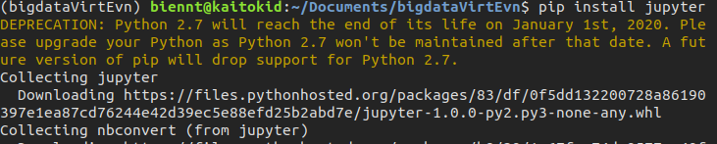
pip install jupyter
Download and unzip spark from link: http://spark.apache.org/downloads.html
Copy spark directory to /venv directory like: venv/spark-2.4.1-bin-hadoop2.7
Edit file ~./.bashrc, add the following lines:
# Setting jupyter notebook
export PYSPARK_DRIVER_PYTHON=/path/to/venv/bin/jupyter
export PYSPARK_DRIVER_PYTHON_OPTS='notebook'
#Setting spark
export SPARK_HOME=/path/to/venv/spark-2.4.1-bin-hadoop2.7
export PATH=$SPARK_HOME/bin:$PATH
export PYSPARK_PYTHON=/path/to/venv/bin/python

#Example:
#export PYSPARK_DRIVER_PYTHON=/home/biennt/Documents/venv/bin/jupyter
#export PYSPARK_DRIVER_PYTHON_OPTS='notebook'

#export SPARK_HOME=/home/biennt/Documents/venv/spark-2.4.1-bin-hadoop2.7
#export PATH=$SPARK_HOME/bin:$PATH
#export PYSPARK_PYTHON=/home/biennt/Documents/venv/bin/python

Come back activated environment venv:
cd spark-2.4.1-bin-hadoop2.7
./bin/pyspark
#Click link localhost to code
